Homework 7 – Circuits

Jamie Gashler – Java Programming

* Constructor chaining is the process used to perform multiple tasks in a single constructor rather than creating code for each task in one constructor. The impact this has on our code is that it allows for more readability as it means you can initialize in one location while displaying multiple constructors to the user.
* The difference between overloading and overriding is that overloading happens when multiple methods in one class have the same method name, but contain different parameters, whereas overriding occurs when there are two methods with the same name and method signature. Overriding requires parent and child classes, while overloaded classes do not.
* A specific example of runtime polymorphism in my code is found in the class Main where the getResistance() method is called, and it doesn’t know which overridden method of getResistance() to use until the program is physically running.
* The difference between abstract and concrete classes are that abstract classes can have both abstract as well as concrete methods. A concrete class is a subclass that can only have concrete methods. It extends the super abstract class which it extends. The abstract class is declared by its keyword “abstract” and cannot be instantiated directly.
* An abstract method is a method that is declared without braces, and followed by a semicolon.
* Final is used to prevent inheritance whereas abstract classes depend upon their child classes to be completely implemented. For methods, final is used to prevent overriding whereas abstract methods needs to be overridden in sub-classes.

**Code Output:**

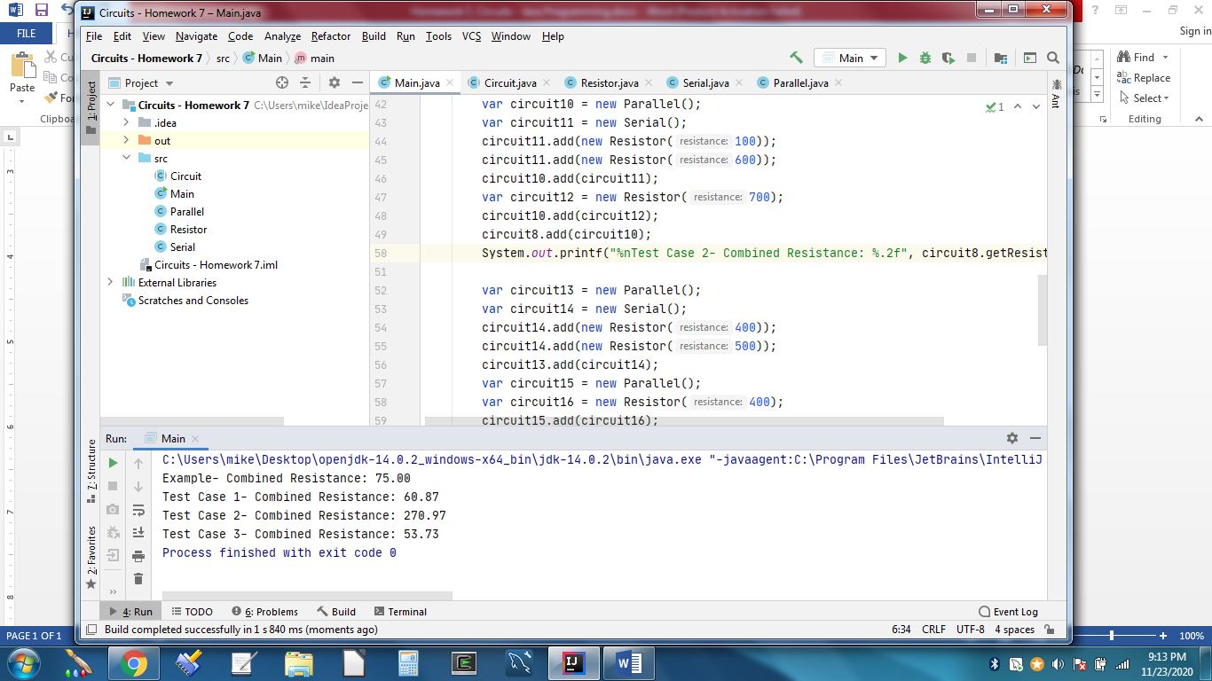

**Test Case 1:**

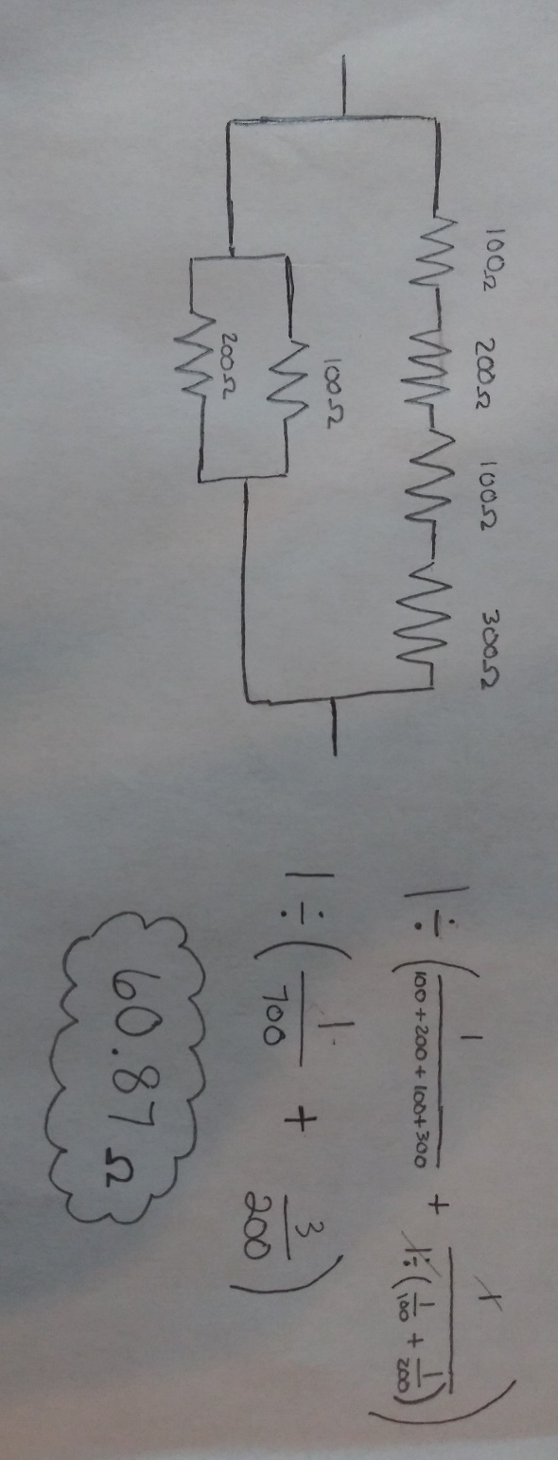

**Test Case 2:**

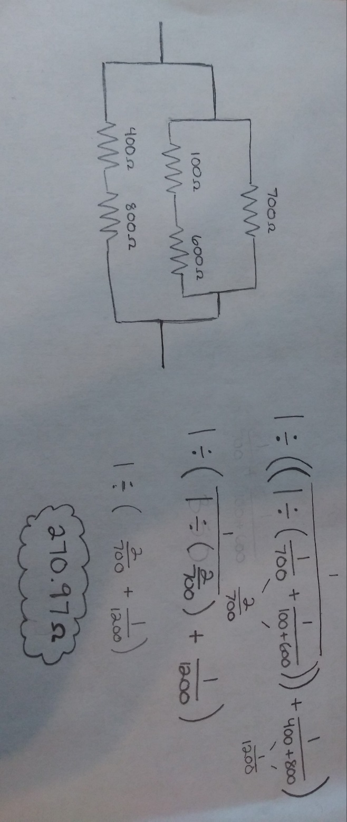

**Test Case 3:**

